LinkedIn

1. Logon to linkedin.com in your web browser. You’ll see a form with 4 fields namely First Name, Last Name, Email or Phone and Password, required to fill to sign up for LinkedIn. Fill these entries correctly and then click on ‘Join Now’ to proceed to the next step of the process.

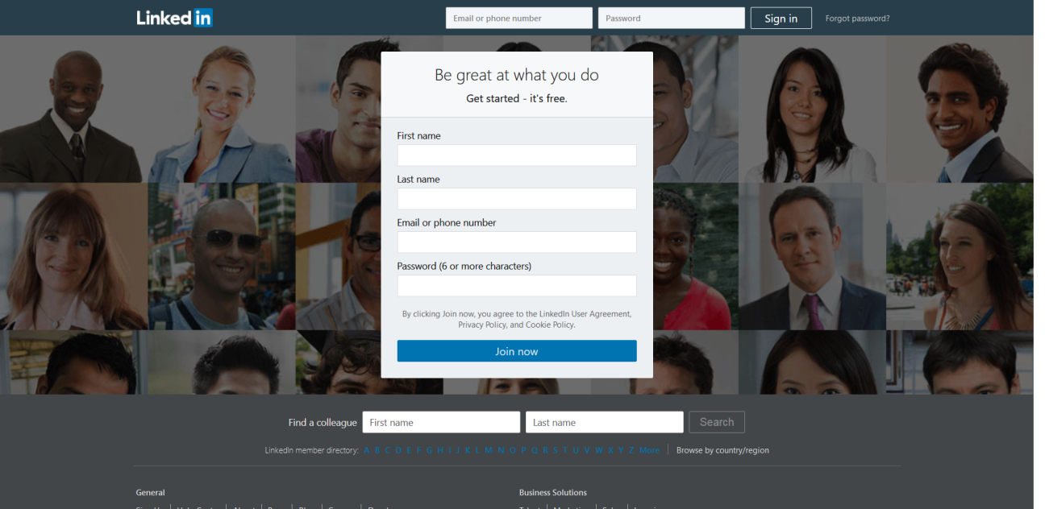

1. **At the next step, click the box below "Country", d**oing so will prompt a drop-down menu of countries, and select your current country of residence. Type in your current ZIP code. You'll do so in the "ZIP code" box below the "Country" box.

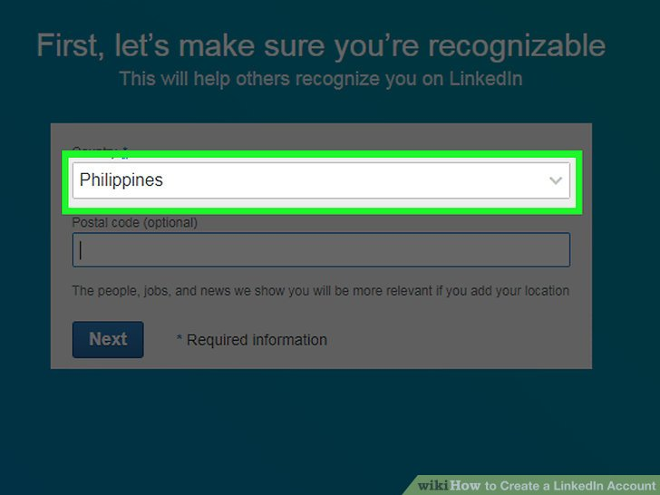

1. **Indicate whether or not you're a student.** To do so, click the **Yes** or the **No** box at the top of this page.

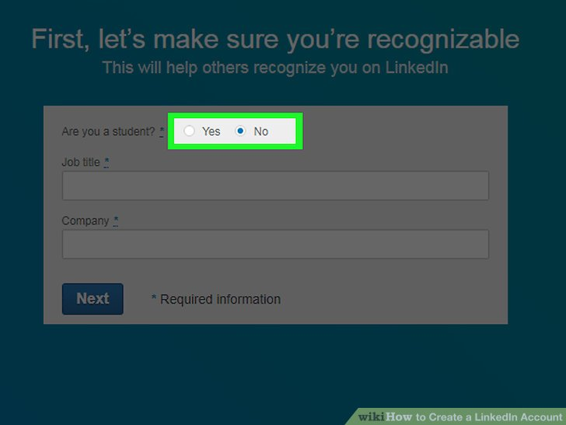

1. Type in your job title and the company at which you work. You'll do so in the "Job title" and "Company" fields on this page.
   1. Depending on your place of employment, you may also have to select a field from an "Industry" box on this page.
   2. If you're a student, you'll type in your current school, the year at which you started school, and when you plan to graduate.

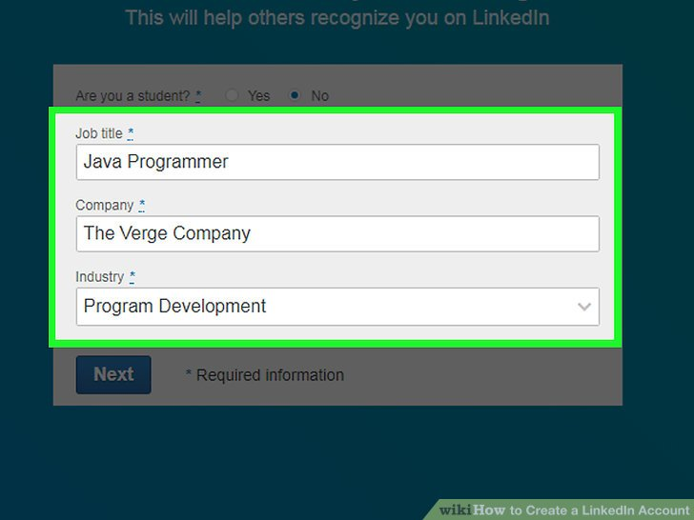

1. Open the email account used to register on LinkedIn. Open the verification email. It may take a few minutes for the email to get delivered. Click the link in the email to activate your account. To finish creating your account, you need to confirm your email.
2. Decide whether or not to import contacts. If you want to import contacts from your email address, click Continue. Otherwise, click Skip.
   1. Choosing to import contacts will prompt you to allow LinkedIn access to your email account, and you'll need to check each person you wish to add on LinkedIn.
   2. If you click Skip, you may need to click a pop-up Yes to confirm your decision.
3. Now you'll need to customize the kind of content and connections you want to see on your LinkedIn Home page.